MOUNTING&WIRING

WARNING:
Improper Inatallalon may cause clectical shock,freorequpmen damaga. The person periomlng the Instalabon muat be famlar with the constuckon and oper bon of the product and aeodaladhzd

1 |  | 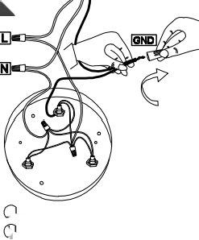  2  O Bck Iio in he wio who linoin neuhi wire  ⑤Wven erir tho calng nd togln | 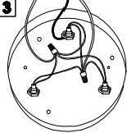
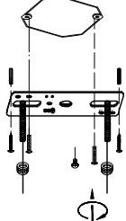
 |  |  | 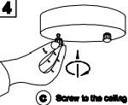

Wire Connection Diegram:
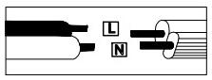

Pleeo prooeed inandlphabetledl order:
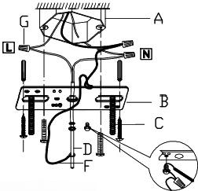
A.Exlating Elaxtrica BOX B.Cronbr C.Crosbr Scnowe D.Cround Wre E.Canopy F.Wo GJunolon Cape
atach the crossber(B)o tho exdiadng oluotioal bodA)ualng theo tbwo crosbr scrowe(C)hich aro not suppied and choud aleady In
your box.Pam the madn wreF}and ground wre(Djthrough tho canopy(E)nd the crosab(Bundi the end of the maln
wre(Feaches the ekactic box
(Awhere you oan wire uo clooutolan oonnedion.Be sure when
connsclng the who u ckoctlcn approved juncton capa(C)sow
the e000s wloIin the caotiodl bodAlniso the canopy(E),ach oanopy(E)o osllng.and hok the oanopyF

DIMENSION

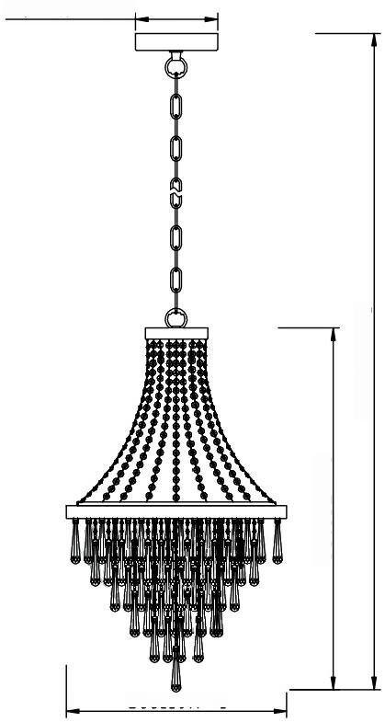
830[32.7、[
1800[70.9[
120[4.724]十

500[19.7]

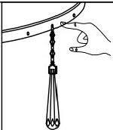
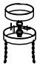
You can reduce the
drop height of fhe
fitting by removing
the chain links to
⑬x30 x18
⑫x24 ⑩x12
⑧x1

NO | 1 | 2 | 3 | 7
COMPONENT | 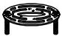 | 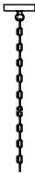 |  | 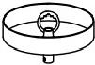 | 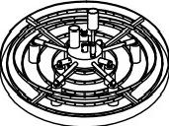
QUANTTY | 1 | 1 | 1 | 1 | 1
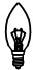

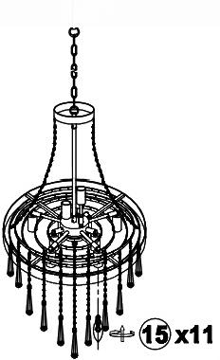
desired length
2
DIMMABLE:fully dimmable with compatible dimmer
switch to create the perfect atmosphere
Type of Light Source:
incandescent,LED or CFL
Bulbs.Bulb base E12,60 watts maximum(not included)
E12
E12

NO | 14 | 13 | 12 | 11 | 10 | 9 | 8
COMPONENT | 患的锡锡9语●第锡●锡书的语图锡带● |  |  | 0 |  |  | 1
QUANTITY | 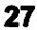 | 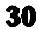 |  | 18 | 12 | 6 | 1

