MOUNTING&WIRING

WARNING:
Improper Inst lalon my cauo electiedl shock,fre,orequpmentdmgs. The perGon perfomlng thoInstalabon must be famlar wth the constuclon and operablon of the product and 8ssodalod hazards

1 |  | 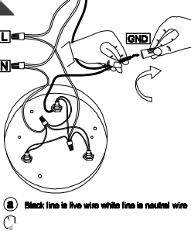  2  ⑥Wven erir tho calng nd togln | 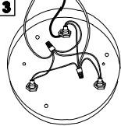
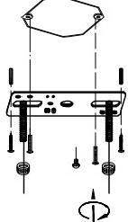
 |  |  | 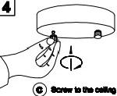

Wire Connection Diagram:
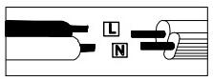

Pleeee proceed In analphabeteal order:
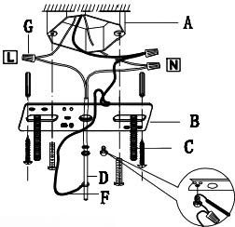
A.Existing Elextrical BOX B.Crossbar C.Crossbar Scrows D.Ground Wie E.Canopy F.Wre G.Junclon Caps
atach the croasbar(B%o the existlng oleotical box(A)ualng the two crossbar scrowe(C)which are not supplied and should alresdy in
your bax.Pass the maln wie(F)and ground wre(D)through the canopy(E)and the crossber(B)unti the end of the main
wie(F)resches the cloctrical box
(A)where you can wlre use eleoticlan connedions.Be sure when
connecing the wire uso ekoctrician approved junction caps(C).stow the eXD88s wire in the electrical box(A).raise the canopy(E),aftach canopy(Ej)o cellng.and hold the canopy(E)

DIMENSION

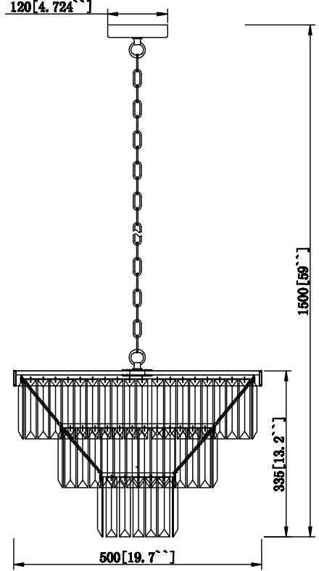

NO | A | B | C | D
0OrP0T | 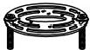 | 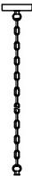 | 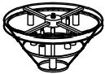
QDMNTITT | 1 | 1 | 1 | 110

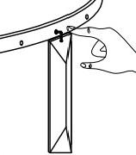
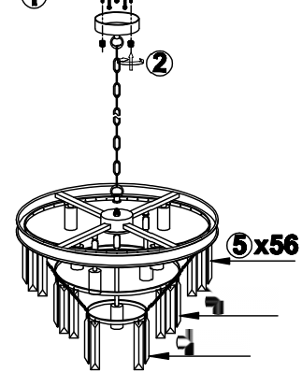

④x36 ③x18
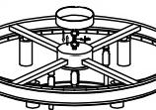
You can reduce the
drop helght of the
fuing by removing the
chaln Iinks to deslred
length
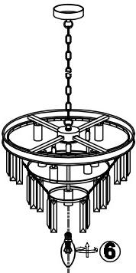
2

NO
0P0T
QLNTITY

DIMMABLE:fully dimmable with compatible dimmer
switch to create the perfect atmosphere
Type of Light Source:
incandescent,LED or CFL
Bulbs.Bulb base E12,60 watts maximum(not included)


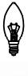
E12

E12

