MOUNTING&WIRING

WARNING:
Improper Inst lalon my cauo electiedl shock,fre,orequpmentdmgs. The perGon perfomlng thoInstalabon must be famlar wth the constuclon and operablon of the product and 8ssodalod hazards

1 |  | 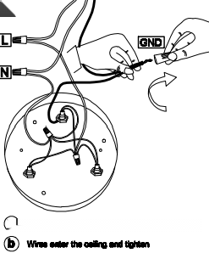  2  O Blaek Ihno t lbe who wito Ihno la nurd we | 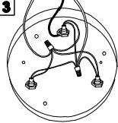
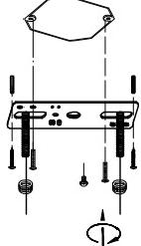
 |  |  | 8cw thecalig

Wire Connection Diagram:
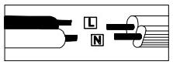

Pleese proceed in an alphabetical order:
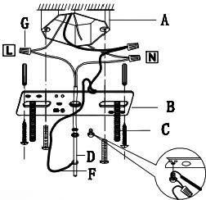
AExieting Elextrical BOX B.Crossbar C.Crossbor Serws

D.Ground Wire ECanopy F.Wire G.Junction Cape
attach the crossbar(Byo the existing electrical box(A)using the two crossb scrow(C)which ar not supplled and should
alrnady In your box.Pas the main wire(Fand ground
wire(D)through the canopy(Eand the crossbar{B)until tho ond of the main wire(Freaches the cectical bax
(A)where you can wine uee olectriclan connectiona.Bo sure when connocting the wire ca oloctrician approved junction
capc(G)stow the excess wire in the clectrical box(A)Lraige tho canopy(E),ttach eanopy(E)to celing,and hold the canopy(

DIMENSION

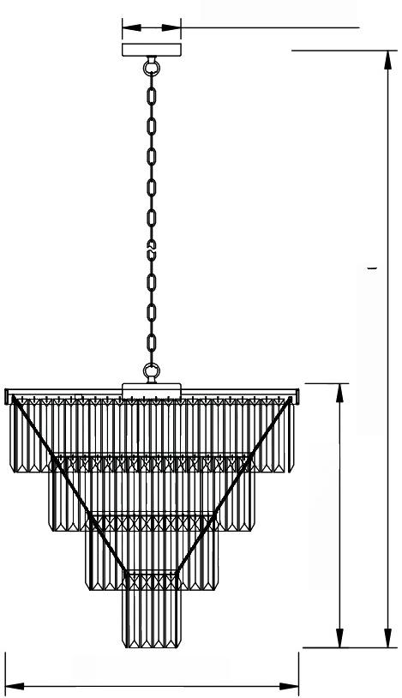
540[21.3;]
2600[102.3:]
0120[4.72``]

2600[23.6 `]

PART LIST | INSTALLATION&MOUNTING INSTRUCTIONS
  NO |  |  |  | 
  comPoNET | 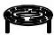 | 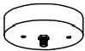 |  | 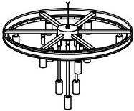
  GUAMTY
  NO |  | 
   | 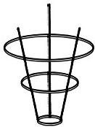 | 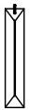
  GUATITY |  | 
 | 1 | 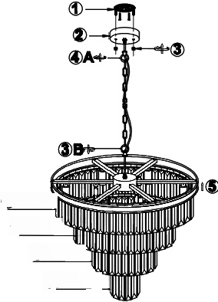  ⑦d x68  ⑦cx52  ⑦bx32  ⑦ax12  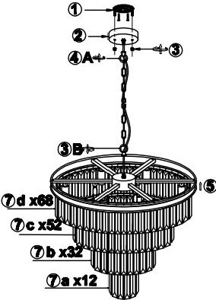 |  |  | 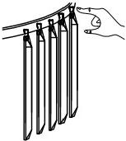  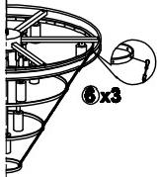
 |   2 |  |  | 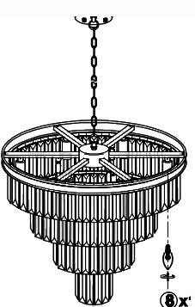  12
DIMMABLE:tuily dimmeble with compatible dimmer swich to
create the perfect atmosphere
Type of Light Source:
incandescent,LED or CFL
Bulbs.Bulb base E12,60 watts maximum(not included)
 |  |  | 
 | E12 E12

