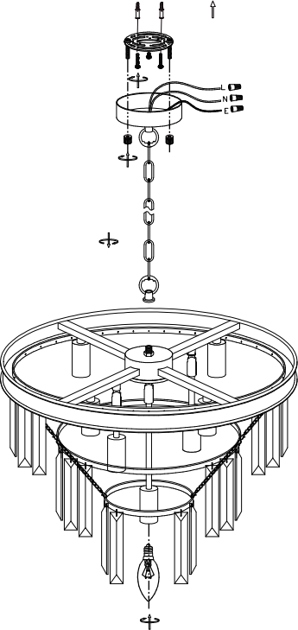
1

L5007
OFF
Rated Voltage AC120V~60Hz
2
To ensure correct function and safety, please read and follow all instructions carefully before assembly, installation and use of the product. Please keep instructions for future reference.
3
Safety Tips
6

7
Always ensure the power is OFF and the fitting has cooled down before performing any maintenance, cleaning, changing the globe or making any adjustment to the fitting.
The external flexible cable or cord of this luminaries cannot be replaced; if the cable or cord is damaged, the luminaries shall be destroyed.
To avoid injury or damage to the fitting, ensure that power leads and screws are secure before connecting the power.
Young children should be supervised to ensure that they do not play with the portable lamp.
Handle the fitting and/or shade with care to avoid any damage or breakage.
Select a suitable location away from liquids and hazards.
Ensure that the fitting does not come in contact with corrosive chemicals, etc.
5
To clean, wipe with a damp clean cloth. Never soak the fitting with water.
4
Installation Requirements:
Select a suitable location for this light fitting:
Ensure it is on a flat and stable surface.
This product is suitable for indoor use only.
Do not place flammable material near or over the fitting.
Ensure the fitting is not installed in direct line of an air vent/system.
If the fitting is placed in an area prone to moisture, ensure that the area is well ventilated and an appropriately rated exhaust fan is used if required. Damage or corrosion caused by moisture is not a product fault, and as such is not covered under warranty.
Do not exceed the maximum wattage rating.
Take care not to pull any electrical wires during unpacking as this may damage the connection.
Lay out all the components on a smooth surface and make sure there are no components missing before assembling. If parts are missing, return the complete product to the place of purchase for inspection or replacement.
11x56pcs
Check whether the fitting has been damaged during transport. Any defect problem, please feel free to tell the seller the specific problem, the seller will solve it for you ASAP.
Do not plug into the mains power socket outlet before or during assembly. Only do so after the portable lamp is fully assembled with the globe installed and is ready to use for the first time.
10x36pcs
Installation Directions:

I: Drill suitable holes into the ceiling, ensuring that they align with the holes in the bracket. Install wall plugs (1) into the holes.
II: Use screws(3) to fasten the metal bracket(2) on the ceiling.
9x18pcs
III: Assemble the chain(5) to threaded joint (4).
IV: Connect power cords to the lamp connector terminal:
[Wire color coding in Norther America: Black for “L”, White for “N”;]
[Wire color coding IEC: Brown for “L”, Blue for “N”, green-yellow for earth wire “E” ]
V: Use nuts(7) to fasten the canopy(6) to metal bracket(2).
VI: Screw light bulbs (8)( not included) into the lamp socket and make sure it does not exceed the maximum wattage specified on the label.
8x7pcs
VII: Hang the crystals(9)(10)(11) on the frames.

